# Lab 3: State Estimation

## Introduction

State estimation (SE) is a crucial process in power system operation, enabling operators to obtain updated models of the system's operational conditions based on real-time measurements. It involves inferring the internal states of the system from external measurements, which is essential for ensuring grid observability and facilitating network control activities. Despite advancements in sensor, communication, and information technologies, achieving observability in power grids remains a challenge. Monitoring alone does not guarantee observability. Instead, it requires the ability to estimate internal states based on monitored outputs.

## Formulation of the SE Problem

The SE problem aims to identify a state vector that explains the available metering data through a known network model. This involves characterizing the power system's condition by determining the voltage magnitude and phase angle at each bus, represented by the state vector. The metered variables are expressed as a non-linear function of the state vector, which depends on the grid's admittance matrix. SE represents a new kind of problem where the goal is to find a vector variable that makes the model a good estimator. Unlike prediction problems, SE deals with a single multidimensional outcome, making it complex due to the high-dimensional nature of the model function.

## Addressing Low-Observability in Distribution Grids

In medium and low voltage-distribution grids, real-time monitoring is limited, leading to ill-conditioned estimation problems. To address this, historical measurements and statistical information are often used to augment the available data. However, relying on pseudo-measurements can lead to poor accuracy in estimation. To handle noisy input data, conventional SE techniques can be adapted by weighting the accuracy of measurements. By assigning higher weights to accurate real-time measurements and lower weights to pseudo-measurements, the estimation accuracy can be improved, mitigating the impact of measurement errors.

## 1º State Estimation considering complete information about currents I12 and I54 (amplitude and angle) and not estimating V3

In the first part of the exercise, we estimate without uncertainty, leading to accurate results.

$$x=\left(\begin{aligned}V_{1} \\ V_{2} \\ V_{4} \\ V_{5}\end{aligned}\right)=\left(\begin{aligned}0.885−0.243j \\ 0.880−0.254j \\ 0.948−0.117j \\ 1+0j\end{aligned}\right)$$

## 2º State Estimation considering RMS information of currents $I_{12}$ and $I_{54}$ and estimating $V_{3}$

Here, we compare our estimations, first without weighting, and second with weights. As we can see in Figure 1, the results are much more exact, when using weighting, as the reduced relative mismatch shows. However, we know, that something is wrong with our weighted results. As we could not find the error, we have left it as it is, with the qualitative result being the same.

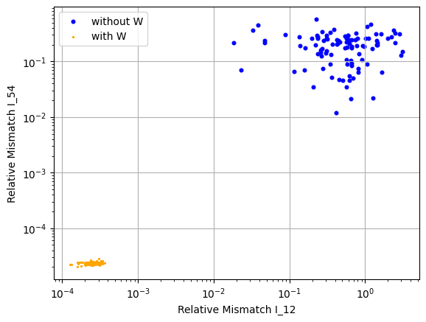

Figure 1

## Assuming we have to chose just two out of four possible pseudo-measurements

Now, we iterate through the different possible pseudo measurements and compare the results. The results can be seen in Figure 2.

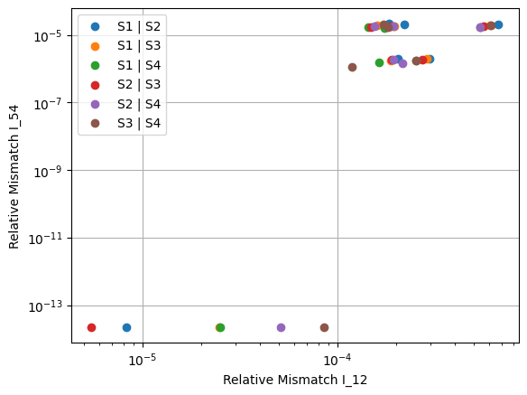

Figure 2

The relative mismatch is lowest for the combination $S_{3}|S_{4}$. Therefore, if we had to choose just two pseudo measurements, we would choose those.